**Assignment 1 - ST1002 – Ross Finnegan**

**Good Graphs:**

1. 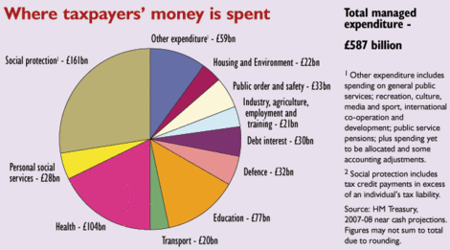

This is a pie chart relating to the different proportions of taxpayers’ money and where it goes. I believe the pie chart highlights the effective visual nature of a pie chart. The use of different colours make the boundaries between different sectors very clear and easy on the eye. I also think that the labelling is very simple and exact, making it very easy for the reader to quickly absorb the information being displayed. The use of the right side of the image to add additional information is very clever and successfully avoids clutter.

Link: http://conservativehome.blogs.com/torydiary/2007/05/more_labour_pro.html

1. 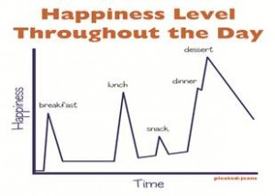

This simple graph demonstrates the relationship between time of day and happiness levels. This graph is quite entertaining and the subject matter is quite fun and entertaining. This is important as graphs are often perceived to be boring. Although this graph isn’t overly serious the fundamentals are still in place as the axes are clearly labelled and the simplistic nature of the graph make it very easy to read.

Link: <http://laughinglindsay.com/2012/06/i-love-charts-book-giveaway/>

**Bad Graphs:**

1. 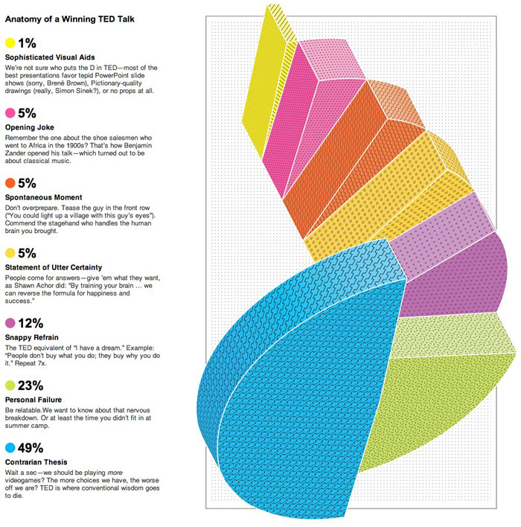

This 3D pie chart attempts to convey the percentage composition of a TED Talk. The graph is a terribly unclear illustration of the percentage of subject matter in TED Talks. The 3D graphic is impossible to comprehend and the splayed portions of the pie make it look like a mess. Although a lot of effort has been put into the graphic it certainly has not made it any way easier to understand for the reader.

Link: <https://wpengine.com/blog/ugly-side-data-visualization/>

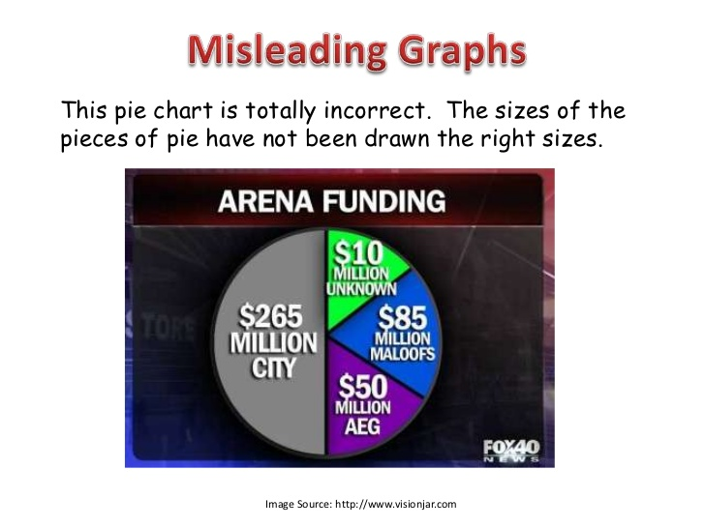



This pie chart is an attempt to display the proportions of funding given towards an arena in the United States. Fox News are notoriously inaccurate when presenting graphs and charts. The above example shows their complete oversight of the size of each portion in the pie chart with the green $10 million segment almost equal to the purple $50 million segment. Mathematical mistakes are a common error in graphs.

Link: <http://image.slidesharecdn.com/misleadinggraphsppa-120318200238-phpapp01/95/misleading-graphs-9-728.jpg?cb=1333397302>